NAME : B Tharun kumar reddy

REG NO : 192111508

COURSE : SOFTWARE ENGINEERING

CODE : CSA1001

FACULTY : DR.G.Mary valantina

DATE : 27/09/22

EXPERIMENT:6

Draw a USE-CASE diagram for ATM System using CASE tools.

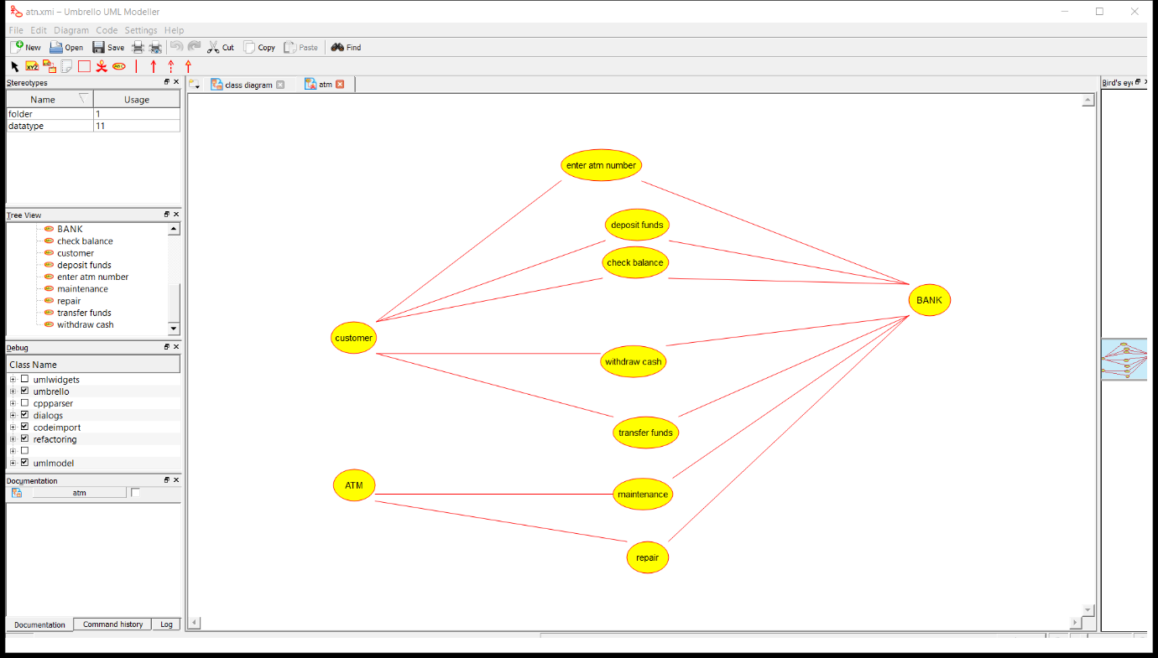

RESULT: I had successfully completed this experiment using umbrello soft ware

EXPERIMENT:7

Draw a USE-CASE diagram for Online Shopping System using CASE tools.

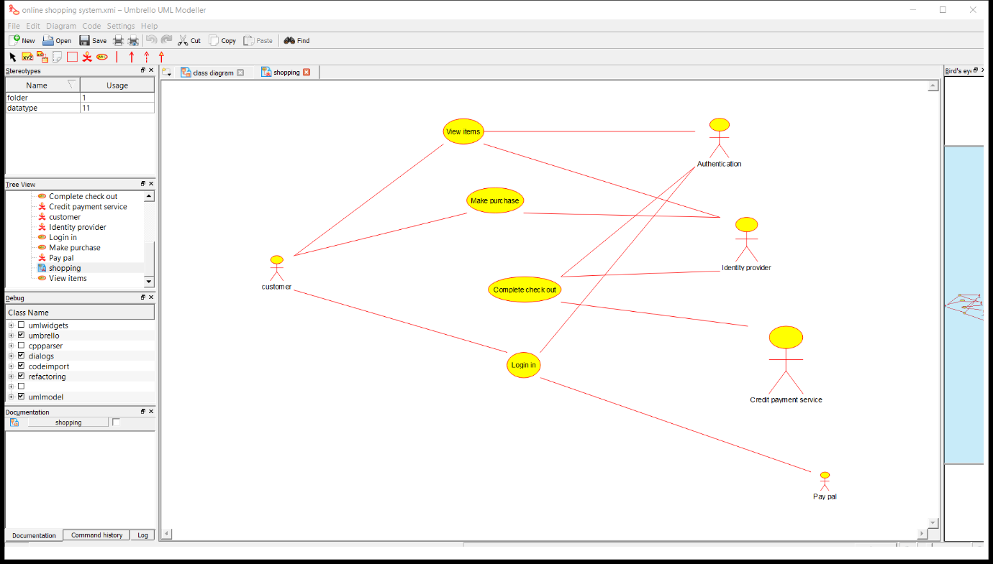

RESULT: I had successfully completed this experiment using umbrello soft ware

EXPERIMENT:8

Draw a USE-CASE diagram for Online Airline Reservation System using CASE tools.

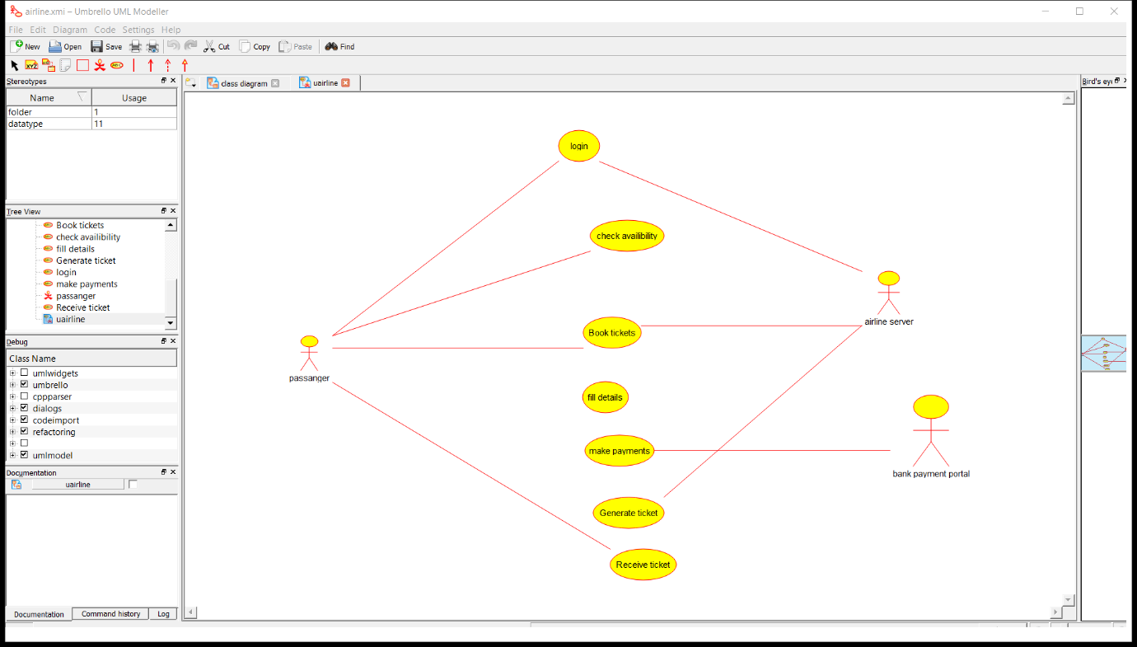

RESULT: I had successfully completed this experiment using umbrello soft ware

EXPERIMENT:9

Draw a Class diagram for Online Airline Reservation System using CASE tools.

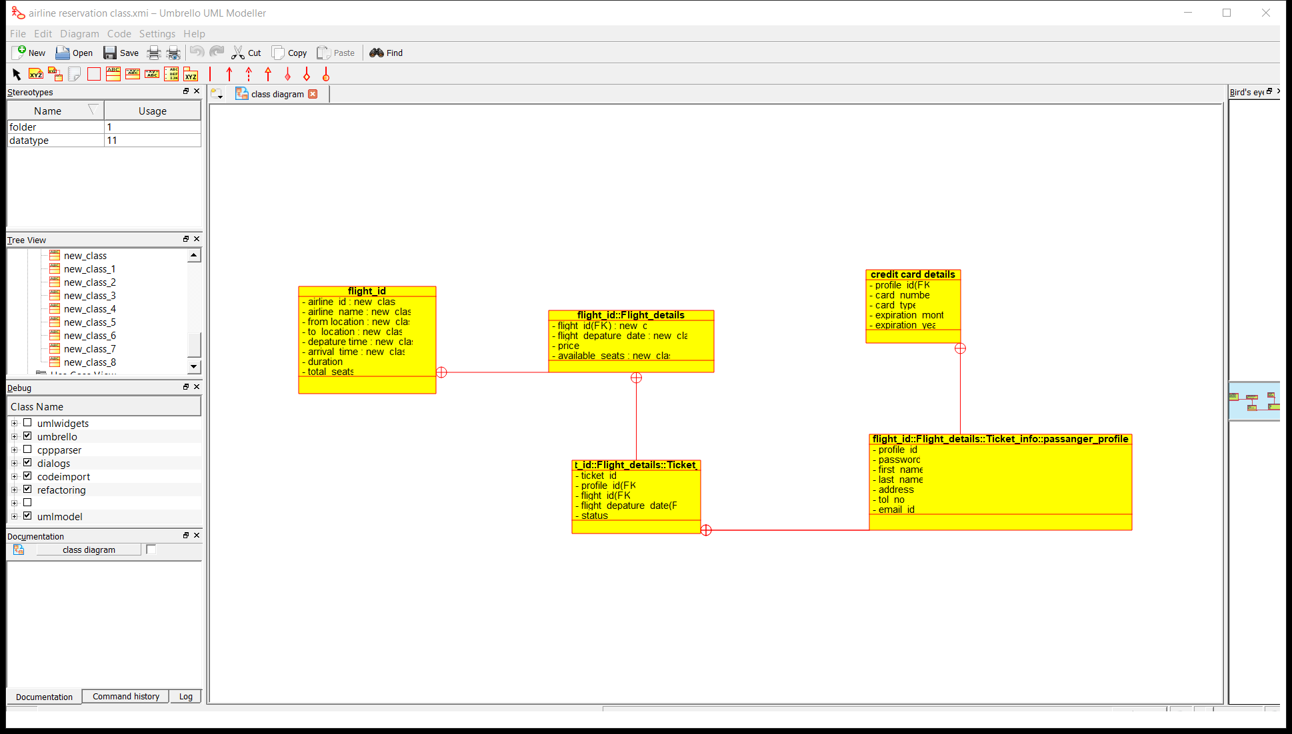

RESULT: I had successfully completed this experiment using umbrello soft ware

EXPERIMENT:10

Draw a Class diagram for Online Voting System using CASE tools

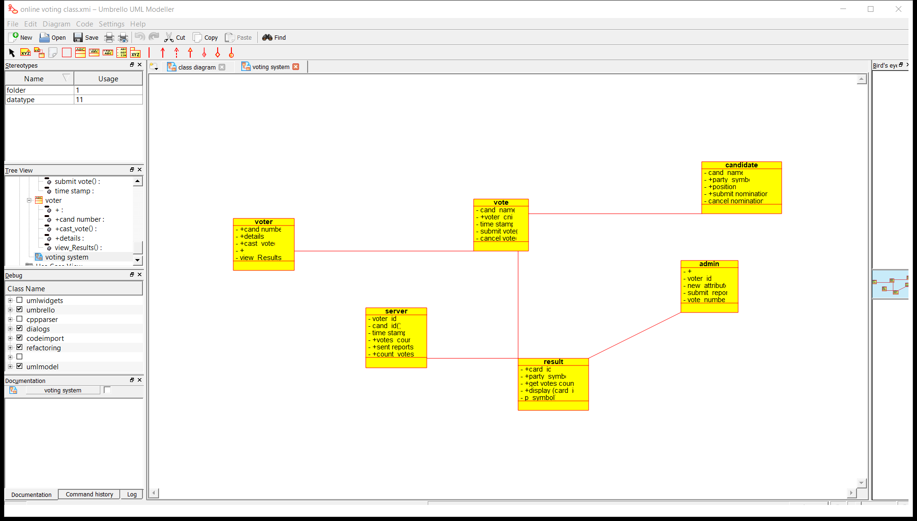

RESULT: I had successfully completed this experiment using umbrello soft ware